
BASE VRE SHUTTLE
Telephone (703)784-2900 Facsimile (703)784-2309
2013 Barnett Ave, Quantico, VA 22134


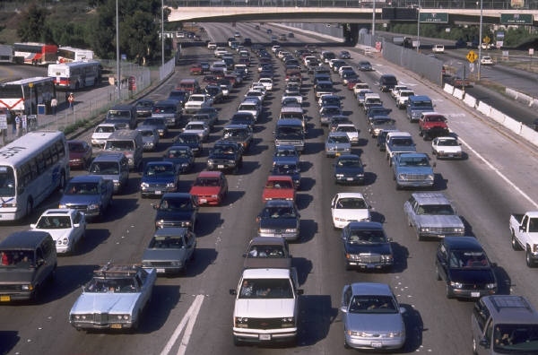
MCB QUANTICO
A shuttle service that will transport Marine Corps Base Quantico Virginia Railway Express (VRE) commuters to their work locations, reducing traffic congestion on base and increasing the number of participants using DoD’s National Capital Region (NCR) – Transits Subsidy Program to offset individual commuter costs.

Starts Oct 26, 2009
Morning shuttle pick up at VRE station:
0540 – 0605 – 0630 – 0655 – 0740 – 0805
Afternoon shuttle pickup:
1600 – 1630 – 1700 - 1730

The VRE shuttle service will pick up VRE morning commuters and drop off VRE afternoon commuters at the Little Hall parking lot.
Each route will consist of two vehicles traveling in opposite directions for pick-up and drop off of passengers.
Morning pick-up at the Little Hall parking lot will coincide with the scheduled arrival times of the VRE morning trains.
Afternoon pick-up will begin approximately one half hour before the schedule arrival times of the VRE afternoon trains, however, pick-up times may be adjusted based upon traffic conditions.

For additional information:
http://www.quantico.usmc.mil/activities/?Section=Trans or call (703)784-2900

Transportation Branch G-4 MCB Quantico
BASE VRE SHUTTLE
Why put up with traffic when you can have quality of life?

Benefits & Savings:

- Maintenance cost

- Money

- Time

- Gas

Contact information and important links.
- Traffic Management; Transportation and construction information - http://www.quantico.usmc.mil under MCBQ Spotlight & Advisories
- Transportation Branch - http://www.quantico.usmc.mil/activities/?Section=Trans
- Mass Transit Benefits - http://www.whs.mil/DFD/Info/NCRTransitSubsidy.cfm
- VRE - http://www.vre.org
- Commuter Connections - http://www.commuterpage.com/ridehome.htm
- Guaranteed Ride Home Program - http://www.mwcog.org/commuter2/commuter/grh/index.html
- ICE - http://ice.disa.mil/index.cfm?fa=service_provider_list&service_category_id=30&site_id=181

Taxi service provides a safe, on call, no cost transportation service for CAC card carrying Base employees. It provides travel to Base to Base destinations that exceed the minimum walking distance (1 mile). It also reduces the number of vehicles traveling aboard Base and helps to alleviate parking space congestion.

WHO’S ELIGIBLE
- Military personnel, DoD Base employees and Contractors who possess a Common Access Card (CAC).
- Employees’ must be performing official duties and services aboard MCB Quantico to use taxi service.
- Military dependents are not authorized to use this transportation service.

HOW IT WORKS
- Call taxi dispatcher at (703) 432-1615 to request a taxi.
- Provide taxi dispatcher the name of passenger, time for pick up, pick up location & destination.
- Note: taxi service is a one-way destination; return trips require a second request.

All passengers must present a valid DoD Common Access Card (CAC) to the taxi driver prior to transport

Mon – Fri from 0700 to 1630
Closed Holidays

BASE TAXI SERVICE
MCB QUANTICO

Leave The Driving To Us…

